**Project Day 1**

**TEAM GROUP M**

TEAM MEMBERS:

1. Chinmay Kulkarni (leader)
2. SV Kartikeya
3. Kartik MC
4. Hrithik Roshan

**Google colab link:**

https://colab.research.google.com/drive/1CeKrpLP2MEszeBS1lJLOC9MR4n3YGLbA?usp=sharing#scrollTo=sagmlgmjNmFj

**Problem Statement 1: (Keep the relevant data)**

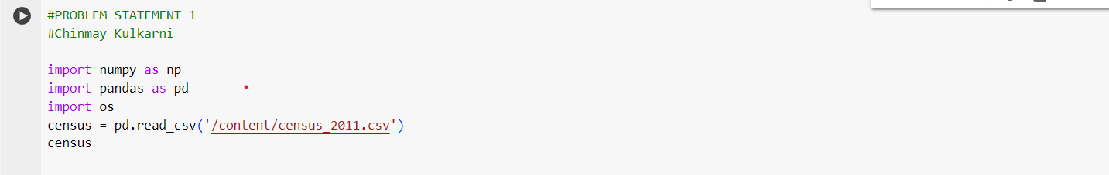



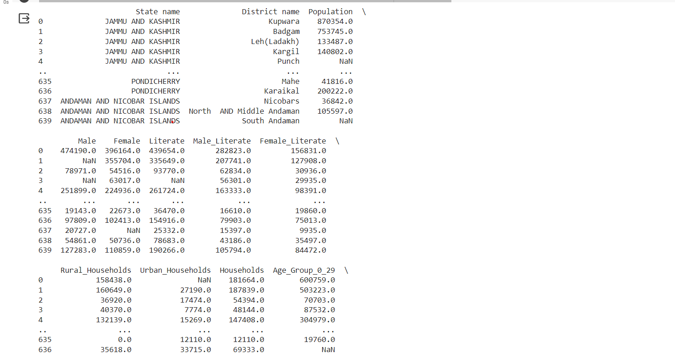

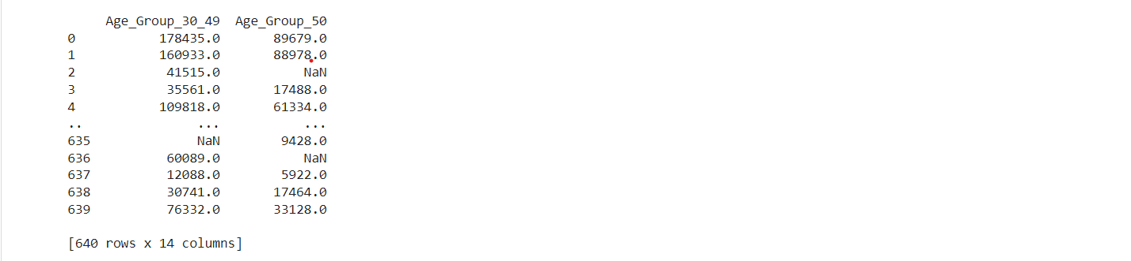

**Problem Statement 2: (Rename the Column names)**

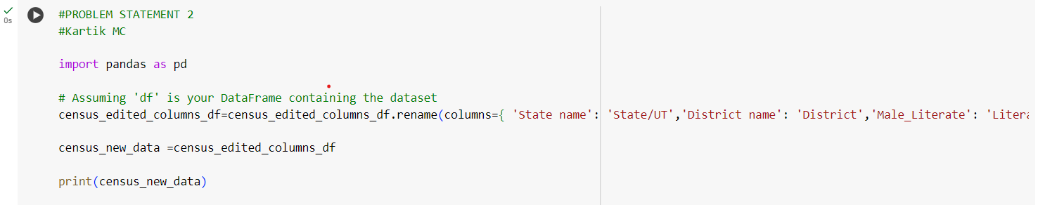

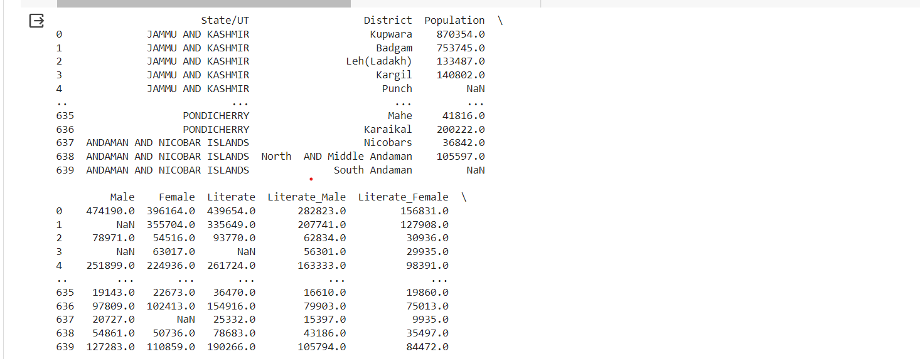

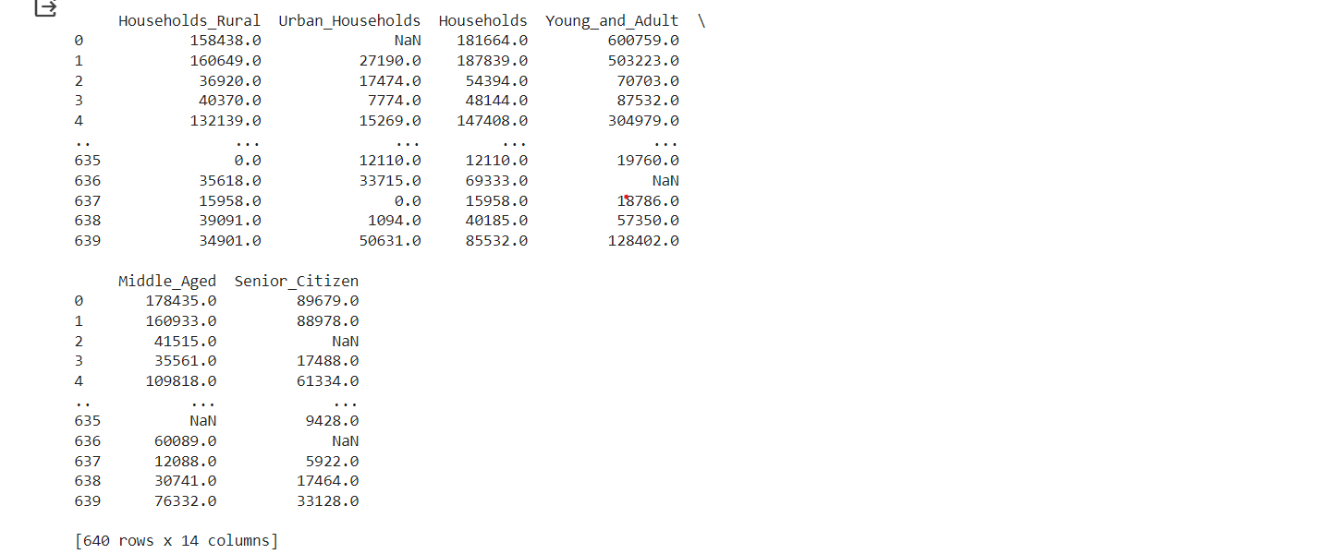

**Problem Statement 3: (Rename State/UT Names)**

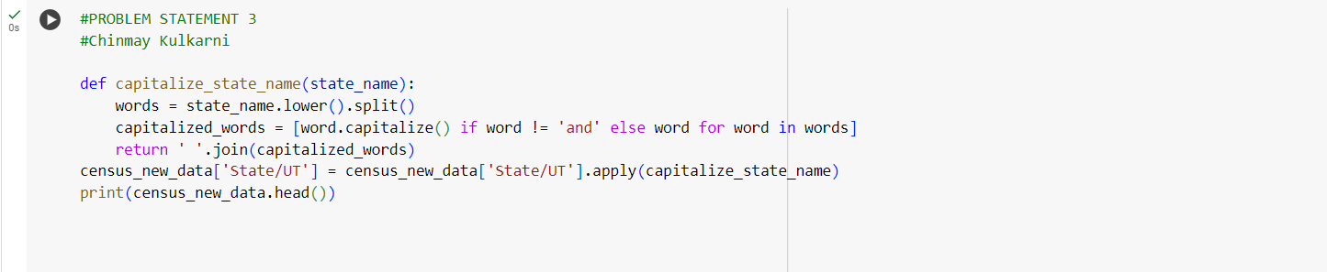

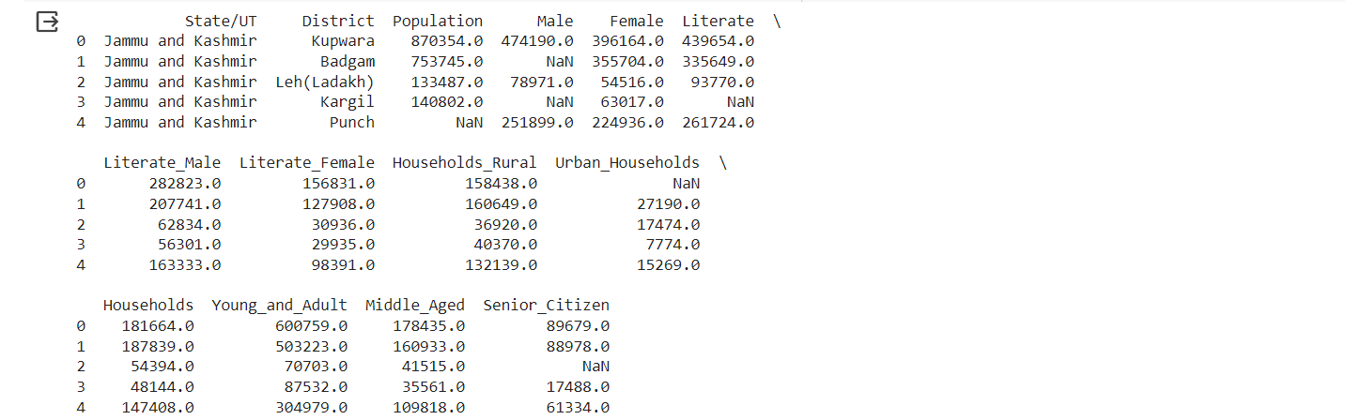

**Problem Statement 4: (New State/UT formation)**

